Ohio New Hire Reporting
REPORTS WILL NUT DE PROCESSED IF REQUIRED INFORMATION IS MISSING
JFS 07048 (Rev. 3/2007) Questions? Call us at (614) 221-5330 or toll-free (888) 872-1490 Ohio Department of Job and Services
Ohio Revised Code section 3121.89 to 3121.8910 requires all Ohio employers, both public and private, to report all contractors and newly hired, rehired, or returning to work employees to the state of Ohio within 20 days of the contract, hire, or rehire date. Information about new hire reporting and online reporting is available on our website: www.oh-newhire.com

Send completed forms to: | To ensure the highest level of accuracy, please print neatly in
Ohio New Hire Reporting Center | capital letters and avoid contact with the edges of the boxes.
PO Box 15309 | The following | will serve as |  |  | an example:
Columbus, OH 43215-0309  Fax: (614) 221-7088 or toll-free fax (888) 872-1611 |  | A |  |  |  | 1 | 2 | 3

EMPLOYEE OR CONTRACTOR INFORMATION

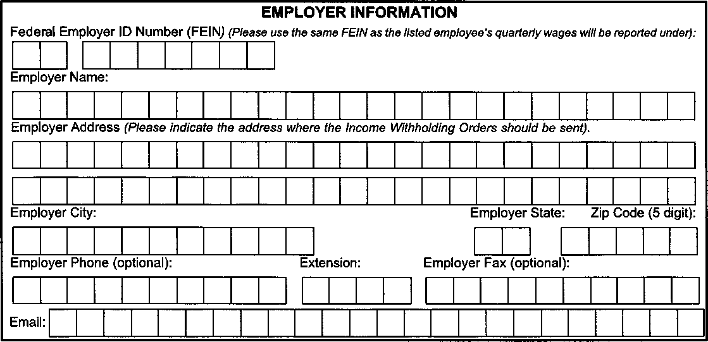
EMPLOYER INFORMATION
Federal Employer ID Number (FEIN) (Please use the same FEIN as the listed employee's quarterly wages will be reported under):
Employer Name:
Emp oyer Address (Please indicate the address where the Income Withholding Orders should be sent).
Employer City.
Employer Phone (optional):
Email:
Extension:
Employer Fax (optional):
Employer State: Zip Code (5 digit)
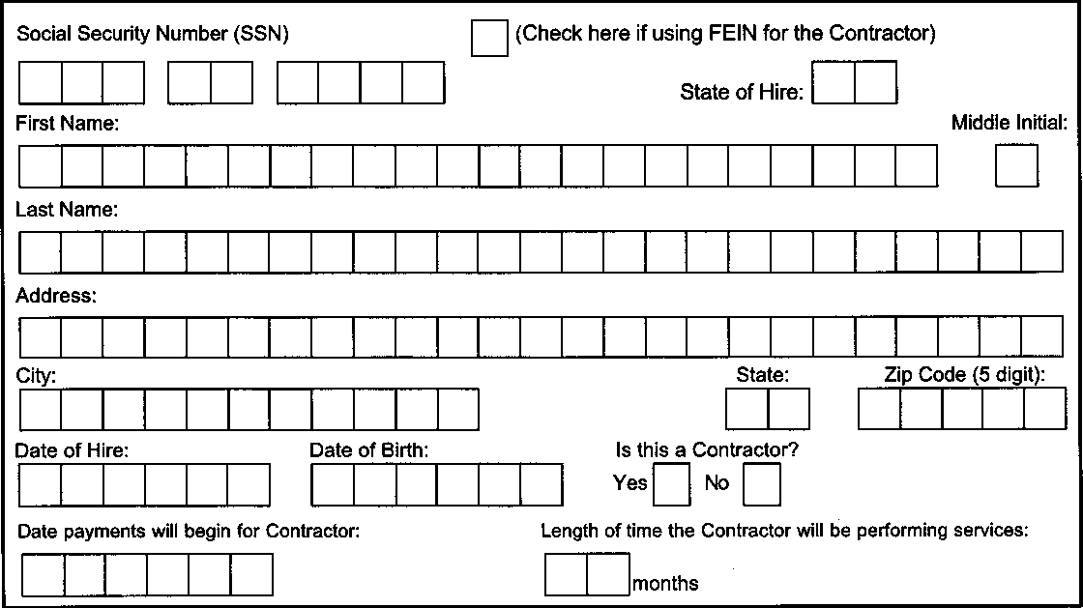
Date of Hire:
Date of Birth:
Is this a Contractor?
Yes I⁻1 No n
Social Security Number (SSN)
First Name:
Last Name:
Address:
(Check here if using FEIN for the Contractor)
Middle Initial:
State:
Zp Code (5 digit):
City:
Date payments will begin for Contractor:
Length of time the Contractor will be performing services:
months
State of Hire:

